**ASSIGNMENT 1**

***Q1. Why do computers understand only binary language?***

***Binary language is used to represent any number using only two numerical numbers 0 and 1. The binary number system is extensively used in the field of digital electronics due to ease of its straight forward implementation. The computer system is also a digital electronic machine that changes raw facts and figures to a meaningful form. In digital electronics, it becomes very easy to define two stages ON and OFF using binary. The number 1 is used to indicate ON whereas the number 0 represents OFF state.***

***Q2. What is the full form of IDE?***

*The full form of IDE is an Integrated Development Environment. It is a software used for building applications that combines common developer tools into a single graphical user interface (GUI).*

***Q3. What is the difference between a text editor and a code editor?***

*A text editor just displays plain text in one colour (black on white, usually, often with monospaced font), with more or less advanced facilities (search, replace, perhaps with regexes, macros / automation, etc.). A good text editor might be optimized to handle very large files, etc.*

*Code editor is one of the most important tools for programmers specifically designed to edit the source code of computer programs. A code editor is basically a text editor but it is also designed to help you write code. It helps you colour your code and provides you more advanced tools to make coding easier for you. A simple code editor can either be a stand-alone software program or part of an IDE or web browser.*

***Q4. What are the steps to develop software using the C language?***

1. ***Create / Edit:****First of all, we need to create a C program for execution. We use an editor to create or edit source program (also known as source code). C program file has extension .C*
2. ***Compile:****After creating or editing source code we need to compile it by using compiler. If compiler does not detect any errors in the program, then it produces object files. Object file has extension .OBJ*
3. ***Link:****Object files are not executable file so in order to make executable file we use linker. If no errors occur, linker produces executable file having extension .EXE*
4. ***Execute:****After obtaining executing file we can run this just like other applications.*

***Q5. Explore by your own***

1. ***What is the latest version of C Language?***

*C17 is the informal name for ISO/IEC 9899:2018, the most recent standard for the C programming language, prepared in 2017 and published in June 2018.*

1. ***Who developed C Language?***

***C****,*[*computer programming language*](https://www.britannica.com/technology/computer-programming-language)*developed in the early 1970s by American computer scientist*[*Dennis M. Ritchie*](https://www.britannica.com/biography/Dennis-M-Ritchie)*at*[*Bell Laboratories*](https://www.britannica.com/topic/Bell-Laboratories)*.*

***3***.***What is the difference between System and Application Software?***

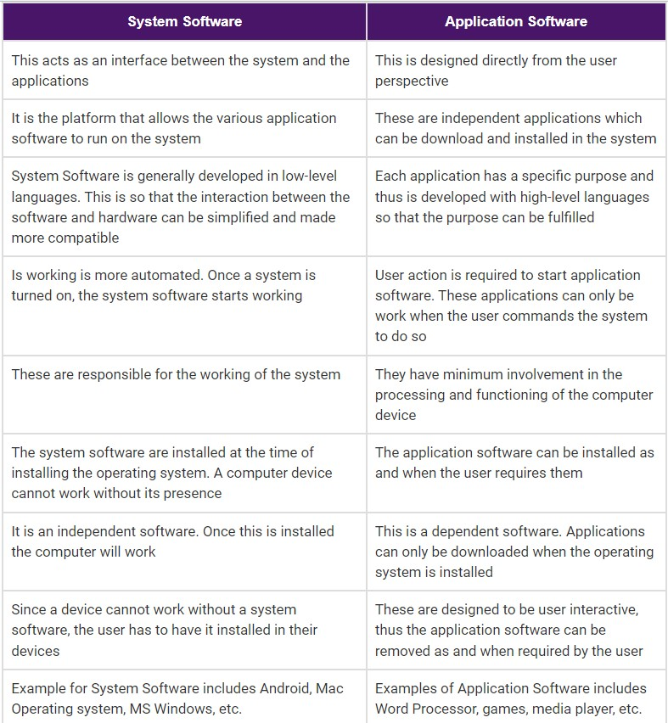

***4. How to convert a number from a decimal number system to a binary number system?***

*Decimal number is a base 10 number because it ranges from 0 to 9, there are total 10 digits between 0 to 9. Any combination of digits is decimal number such as 23, 445, 132, 0, 2 etc.*

*Binary number is a base 2 number because it is either 0 or 1. Any combination of 0 and 1 is binary number such as 1001, 101, 11111, 101010 etc.*

*Steps to convert a number from decimal to binary:*

* *Step 1: Divide the number by 2 through % (modulus operator) and store the remainder in array.*
* *Step 2: Divide the number by 2 through / (division operator).*
* *Step 3: Repeat the step 2 until number is greater than 0.*

